University of Minnesota

Offers at least ten $1,500 scholarships
to new (freshman or transfer) students
with genuine interest in the dairy industry

(Applicants do not need to be formally admitted by the
University of Minnesota at the time of application)

Download the application and type in your responses.
Email completed application to:

ihaagen@umn.edu

Applications must be received by:
January 18, 2026

Questions will be answered by club co-adviser Dr. Isaac Haagen:
(814) 880-2093 or ihaagen@umn.edu

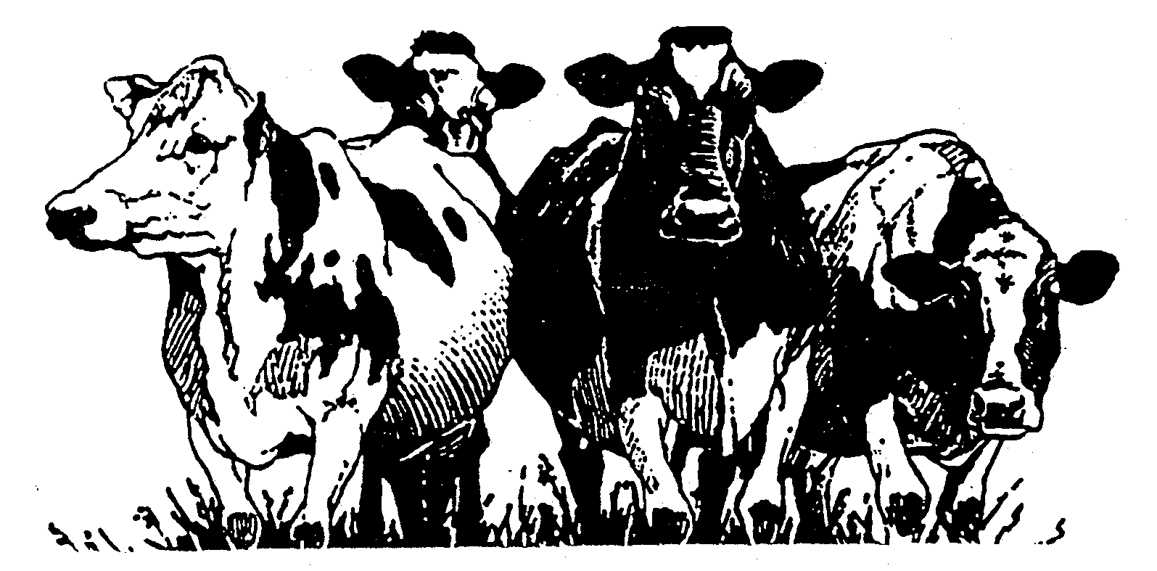
Scholarship Application
Name:
Address:

Cell Phone Number:
E-Mail:
Parent(s) or Guardian(s):
High School:
Anticipated Major:
Anticipated Enrollment Date:
List (in bulleted format) your involvement in organizations and activities and the type of involvement (year of involvement, brief description of involvement, and any leadership role). SEPARATELY list DAIRY versus NON-DAIRY organizations and activities. Please present in a typed and orderly format. Add additional lines as needed.

List (in bulleted format) awards, honors, and recognition you have received (briefly explain each item). Please present in a typed and orderly format. Add additional lines as needed.

Please discuss why you would like to be involved in the Gopher Dairy Club and what you believe you can contribute as an active member. Please present in a typed and orderly format. Add additional lines as needed (limit to 500 words).

Please describe your interest and involvement in the dairy industry. Please present in a typed and orderly format. Add additional lines as needed (limit to 500 words).

Applications must be emailed by January 18, 2026.

Email applications to: Dr. Isaac Haagen
Gopher Dairy Club Co-advisor
ihaagen@umn.edu

